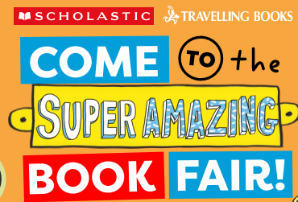

The most exciting time of the year is here!
The Travelling Book Fair will return to Loughries this year on the 21st April – 28th April.
Boys and girls from Primary 1-3 can attend the Book Fair after school from 2pm.
Primary 4-7 can attend the Book Fair after school from 3pm.

The children will also have the opportunity during school time to visit the book fair to browse what is on offer ahead of their allocated visit times.
The children in Primary 7 will be helping you settle the bill. Please bring cash to pay for the books. There will be a fantastic selection of books available to purchase on the day. All proceeds will go towards reading materials for our school.


